**A PROJECT REPORT**

**ON**

**CODEGEN**

Submitted in partial fulfilment of the requirement for the award of Degree of

BACHELOR OF VOCATION

IN

SOFTWARE DEVELOPMENT

Submitted to: Submitted By:

PALLAVI ROY (02650118116)

DHIREN SAHNI (04850118116)



INTEGRATED INSTITUTE OF TECHNOLOGY

December,2018

(Annexure II)

**CANDIDATE’S DECLARATION**

I hereby declare that the work presented in this report entitled “CODEGEN”, in fulfilment of the requirement for the award of the Degree Bachelor of Vocational Studies in Software Development, submitted in IT Department, Integrated Institute of technology, Dwarka Sec-9 , New Delhi affiliated to Guru Gobind Singh Indraprastha University, New Delhi, is an authentic record of my own work carried out during my degree under the guidance of Mr. Inderjeet Yadav Sir.

The work reported in this has not been submitted by me for award of degree.

Date : 13th December 2018

Pallavi Roy Dhiren Sahni

02650118116 04850118116

(AnnexureIII)

**CERTIFICATE**

This is to certify that the Project work entitled “CODEGEN” submitted by Pallavi Roy and Dhiren Sahni in fulfilment for the requirements of the award of Bachelor of Vocational Studies Degree in Software Development at Integrated Institute of technology, Dwarka Sec-9, New Delhi is an authentic work carried out by his and her under my supervision and guidance. To the best of my knowledge, the matter embodied in the project has not been submitted to any other University / Institute for the award of any Degree.

Date: 13th December 2018 Inderjeet Yadav Sir

(Project Incharge)

(Annexure IV)

**ACKNOWLEDGEMENT**

I express my sincere gratitude to Mr. Shashank Gupta (HOD) and Mrs. Damandeep Kaur for her valuable guidance and timely suggestions during the entire duration of my dissertation work, without which this work would not have been possible. I would also like to convey my deep regards to all other faculty members of NIELIT, who have bestowed their great effort and guidance at appropriate times without which it would have been very difficult on my part to finish this work. Finally, I would also like to thank my friends for their advice and pointing out my mistakes.

**TABLE OF CONTENTS**

|  |  |  |
| --- | --- | --- |
| **S.NO** | **TOPIC** | **Page No.** |
| **1** | **Project information sheet** | **1** |
| **2** | **Introduction** | **2** |
| **3** | **Objectives** | **3** |
| **4** | **Work Plan & Methodology** | **4** |
| **5** | **ER Diagram** | **5** |
| **6** | **Source Codes** | **6-25** |
| **7** | **Screenshots** | **26-32** |
| **8** | **References** | **33** |

**Project Information Sheet**

**Specific Title of Project: CODEGEN**

**General Area of Project: Training and Placement company**

**Principal Project Guide: Mr. Inderjeet Yadav Lecturer (Dept. of Computer Science)**

**Platform of Development: Notepad++**

**Language used: HTML, CSS, BOOTSTRAP, JQUERY**

**Principal Developers:** Pallavi Roy (02650118116),

Dhiren Sahni (04850118116)

**Institute: Integrated Institute Of technology, Dwarka, Sector-09, New Delhi (Affiliated to Guru Gobind Singh Indraprastha University).**

**Objective of Project:** Partial fulfilment of the requirement for the award of the degree of Bachelor of vocation (Software Development). Project-III,5th Sem.

**Time Period Involved:** August2018, December2018

**Feasibility:** **Technically Feasible:** The project is feasible as it is possible to create a website that can easily give all the necessary information to the clients about various trainings available and placement opportunities.

**System Requirement: Hardware Requirement (Minimum)**

• Intel core i3 4300u

• 2 GB RAM

• 80 GB Hard Disk  
• Keyboard & mouse

**Software Requirement**

• Operating System: Windows 8.1 or later versions  
• Front end tool: Notepad, Notepad++, Sublime text, HTML, CSS, jQuery, Bootstrap

**Introduction**

**CODEGEN, the Composition of "Computer Education & Technology Promotion Association", believes in quality not in quantity BECAUSE KNOWLEDGE MATTERS.**

CODEGEN is the leader in the “specialized training” brands of India certified by ISO 9001:2015 for its best quality. CODEGEN is the largest training service provider in various IT domains for all IT students as well as for the working professionals. It has an extensive experience of nurturing over 200000+ students in the past few years. CODEGEN has been awarded as the “Best IT and Embedded Training Company” for 5 consecutive years for delivering high quality training and workshops at more than 500 colleges across World. CODEGEN is a trustworthy brand in Education and Training industry with its presence across several cities such as Noida, Roorkee, Lucknow and Dehradun. The company was started 12 years back and it is continuously expanding having its overseas branches in New York, Germany and Ukraine.

**Our Mission**

Motivate. Inspire. Learning and development contributes to the success of organization by partnering with Microsoft, IBM, Oracle, Adobe, VMWare, AWS, Cybereason associates and leaders to drive learning that is strategic, measurable and effective.

## Our Belief

Everybody has got talent, passion & a leader in them. We just need to train and coach them to emerge them as winners in all spheres of life. "Expound the actual teachings of the great truth and the master-builder of human happiness."

## Our Vision

Our efforts are focused on bringing out the best within every individual and epitomizing their capacity to unprecedented levels. Emerging as an acclaimed body for setting training & development standards in India & worldwide.

**USE OF APPLICATION / FEASABILITY:**

* This application makes an easy access to the training courses letting back home.
* It has an online registration option that help students to easily register with us.
* The idea of developing this website is to know more deeply about the growing web applications world with its features and working.

**Objectives**

|  |  |
| --- | --- |
| **Name of project:** | CODEGEN |
| **Project started:** | August 2018 |
| **Developers:** | Pallavi Roy; Dhiren Sahni |
| **Purposes:** | 1. Provide opportunity to apply the theoretical concept to actual situations. 2. To explore the skills for gaining practical knowledge about real life situations. 3. To generate approach and confidence in problem solving. 4. To equip with tools & techniques of gathering, selecting, sorting & analyzing the information for relevant use in practice. |
| **Goal:** | Designing a website with our Clients in mind, Building a website for mobile search, Constructing a website the way Google sees it, Writing contents for our clients and Google. |

**Work plan and methodology**

|  |  |  |  |  |
| --- | --- | --- | --- | --- |
| **SR.NO.** | **Activities** | **Expected Outcome** | **Possible Errors** | **Person Responsible** |
| 1 | Installing Software | Software should work properly | Improper software  Installation causing software or system crashing. | Pallavi Roy  Dhiren Sahni |
| 2 | Creating Home page | Home page should give proper information. | Layout errors | Pallavi Roy  Dhiren Sahni |
| 3 | Creating navigation bar | Different pages are combined in navigation bar for differentiating various categories | Navigation bar not coded properly; height or width does not match the parent | Pallavi Roy  Dhiren Sahni |
| 4 | Creating different pages as given in the navigation bar | The pages should work properly and should be aligned and filled with required information appropriately. | Pages may not show the desired output. | Pallavi Roy  Dhiren Sahni |
| 5 | Managing pages/sections | Individual page/section updates by the admin should be done from time to time. | Pages/sections may not be updated because of incorrect coding. | Pallavi Roy  Dhiren Sahni |
| 6 | Responsive Webpages | Webpages should display all the necessary data to the client and enhance their experience with us with online query solving etc. | Webpage does not show relevant and proper information to the client due to some errors. | Pallavi Roy  Dhiren Sahni |
| 7 | Client registration | New clients can register with us through online mode also. All the information will be saved and records will be maintained for client to easily access when needed. | Client’s information is not saved or updated. Client not able to access due to database non-connectivity. | Pallavi Roy  Dhiren Sahni |

**ER Diagram**

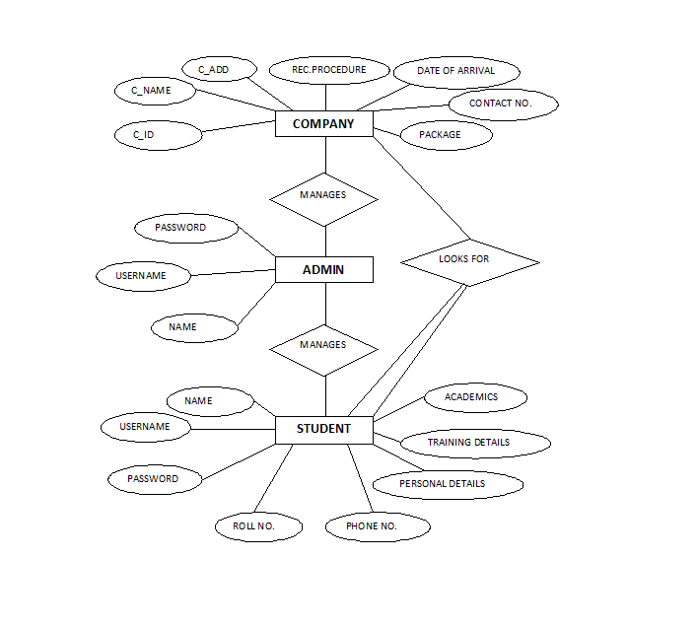

**Source codes**

HOME PAGE SECTION:

<!DOCTYPE html>

<html lang="en">

<head>

<meta charset="utf-8">

<title>BizPage Bootstrap Template</title>

<meta content="width=device-width, initial-scale=1.0" name="viewport">

<meta content="" name="keywords">

<meta content="" name="description">

<!-- Favicons -->

<link href="img/favicon.png" rel="icon">

<link href="img/apple-touch-icon.png" rel="apple-touch-icon">

<!-- Google Fonts -->

<link href="https://fonts.googleapis.com/css?family=Open+Sans:300,300i,400,400i,700,700i|Montserrat:300,400,500,700" rel="stylesheet">

<!-- Bootstrap CSS File -->

<link href="lib/bootstrap/css/bootstrap.min.css" rel="stylesheet">

<!-- Libraries CSS Files -->

<link href="lib/font-awesome/css/font-awesome.min.css" rel="stylesheet">

<link href="lib/animate/animate.min.css" rel="stylesheet">

<link href="lib/ionicons/css/ionicons.min.css" rel="stylesheet">

<link href="lib/owlcarousel/assets/owl.carousel.min.css" rel="stylesheet">

<link href="lib/lightbox/css/lightbox.min.css" rel="stylesheet">

<!-- Main Stylesheet File -->

<link href="css/style.css" rel="stylesheet">

</head>

HEADER SECTION:

<body>

<header id="header">

<div class="container-fluid">

<div id="logo" class="pull-left">

<h1><a href="#intro" class="scrollto">BizPage</a></h1>

<!-- Uncomment below if you prefer to use an image logo -->

<!-- <a href="#intro"><img src="img/logo.png" alt="" title="" /></a>-->

</div>

<nav id="nav-menu-container">

<ul class="nav-menu">

<li class="menu-active"><a href="#intro">Home</a></li>

<li><a href="#about">About Us</a></li>

<li><a href="#services">Services</a></li>

<li><a href="#portfolio">Portfolio</a></li>

<li><a href="#team">Team</a></li>

<li class="menu-has-children"><a href="">Drop Down</a>

<ul>

<li><a href="#">Drop Down 1</a></li>

<li><a href="#">Drop Down 3</a></li>

<li><a href="#">Drop Down 4</a></li>

<li><a href="#">Drop Down 5</a></li>

</ul>

</li>

<li><a href="#contact">Contact</a></li>

</ul>

</nav><!-- #nav-menu-container -->

</div>

</header><!-- #header -->

INTRODUCTION SECTION:

<section id="intro">

<div class="intro-container">

<div id="introCarousel" class="carousel slide carousel-fade" data-ride="carousel">

<ol class="carousel-indicators"></ol>

<div class="carousel-inner" role="listbox">

<div class="carousel-item active">

<div class="carousel-background"><img src="img/intro-carousel/1.jpg" alt=""></div>

<div class="carousel-container">

<div class="carousel-content">

<h2>We are professional</h2>

<p>Lorem ipsum dolor sit amet, consectetur adipiscing elit, sed do eiusmod tempor incididunt ut labore et dolore magna aliqua. Ut enim ad minim veniam, quis nostrud exercitation ullamco laboris nisi ut aliquip ex ea commodo consequat.</p>

<a href="#featured-services" class="btn-get-started scrollto">Get Started</a>

</div>

</div>

</div>

<div class="carousel-item">

<div class="carousel-background"><img src="img/intro-carousel/2.jpg" alt=""></div>

<div class="carousel-container">

<div class="carousel-content">

<h2>At vero eos et accusamus</h2>

<p>Nam libero tempore, cum soluta nobis est eligendi optio cumque nihil impedit quo minus id quod maxime placeat facere possimus, omnis voluptas assumenda est, omnis dolor repellendus. Temporibus autem quibusdam et aut officiis debitis aut.</p>

<a href="#featured-services" class="btn-get-started scrollto">Get Started</a>

</div>

</div>

</div>

<div class="carousel-item">

<div class="carousel-background"><img src="img/intro-carousel/3.jpg" alt=""></div>

<div class="carousel-container">

<div class="carousel-content">

<h2>Temporibus autem quibusdam</h2>

<p>Beatae vitae dicta sunt explicabo. Nemo enim ipsam voluptatem quia voluptas sit aspernatur aut odit aut fugit, sed quia consequuntur magni dolores eos qui ratione voluptatem sequi nesciunt omnis iste natus error sit voluptatem accusantium.</p>

<a href="#featured-services" class="btn-get-started scrollto">Get Started</a>

</div>

</div>

</div>

<div class="carousel-item">

<div class="carousel-background"><img src="img/intro-carousel/4.jpg" alt=""></div>

<div class="carousel-container">

<div class="carousel-content">

<h2>Nam libero tempore</h2>

<p>Neque porro quisquam est, qui dolorem ipsum quia dolor sit amet, consectetur, adipisci velit, sed quia non numquam eius modi tempora incidunt ut labore et dolore magnam aliquam quaerat voluptatem. Ut enim ad minima veniam, quis nostrum.</p>

<a href="#featured-services" class="btn-get-started scrollto">Get Started</a>

</div>

</div>

</div>

<div class="carousel-item">

<div class="carousel-background"><img src="img/intro-carousel/5.jpg" alt=""></div>

<div class="carousel-container">

<div class="carousel-content">

<h2>Magnam aliquam quaerat</h2>

<p>Lorem ipsum dolor sit amet, consectetur adipiscing elit, sed do eiusmod tempor incididunt ut labore et dolore magna aliqua. Ut enim ad minim veniam, quis nostrud exercitation ullamco laboris nisi ut aliquip ex ea commodo consequat.</p>

<a href="#featured-services" class="btn-get-started scrollto">Get Started</a>

</div>

</div>

</div>

</div>

<a class="carousel-control-prev" href="#introCarousel" role="button" data-slide="prev">

<span class="carousel-control-prev-icon ion-chevron-left" aria-hidden="true"></span>

<span class="sr-only">Previous</span>

</a>

<a class="carousel-control-next" href="#introCarousel" role="button" data-slide="next">

<span class="carousel-control-next-icon ion-chevron-right" aria-hidden="true"></span>

<span class="sr-only">Next</span>

</a>

</div>

</div>

</section><!-- #intro -->

<main id="main">

ABOUT US SECTION:

<section id="about">

<div class="container">

<header class="section-header">

<h3>About Us</h3>

<p>Lorem ipsum dolor sit amet, consectetur adipiscing elit, sed do eiusmod tempor incididunt ut labore et dolore magna aliqua. Ut enim ad minim veniam, quis nostrud exercitation ullamco laboris nisi ut aliquip ex ea commodo consequat.</p>

</header>

<div class="row about-cols">

<div class="col-md-4 wow fadeInUp">

<div class="about-col">

<div class="img">

<img src="img/about-mission.jpg" alt="" class="img-fluid">

<div class="icon"><i class="ion-ios-speedometer-outline"></i></div>

</div>

<h2 class="title"><a href="#">Our Mission</a></h2>

<p>

Lorem ipsum dolor sit amet, consectetur elit, sed do eiusmod tempor ut labore et dolore magna aliqua. Ut enim ad minim veniam, quis nostrud exercitation ullamco laboris nisi ut aliquip ex ea commodo consequat.

</p>

</div>

</div>

<div class="col-md-4 wow fadeInUp" data-wow-delay="0.1s">

<div class="about-col">

<div class="img">

<img src="img/about-plan.jpg" alt="" class="img-fluid">

<div class="icon"><i class="ion-ios-list-outline"></i></div>

</div>

<h2 class="title"><a href="#">Our Plan</a></h2>

<p>

Sed ut perspiciatis unde omnis iste natus error sit voluptatem doloremque laudantium, totam rem aperiam, eaque ipsa quae ab illo inventore veritatis et quasi architecto beatae vitae dicta sunt explicabo.

</p>

</div>

</div>

<div class="col-md-4 wow fadeInUp" data-wow-delay="0.2s">

<div class="about-col">

<div class="img">

<img src="img/about-vision.jpg" alt="" class="img-fluid">

<div class="icon"><i class="ion-ios-eye-outline"></i></div>

</div>

<h2 class="title"><a href="#">Our Vision</a></h2>

<p>

Nemo enim ipsam voluptatem quia voluptas sit aut odit aut fugit, sed quia magni dolores eos qui ratione voluptatem sequi nesciunt Neque porro quisquam est, qui dolorem ipsum quia dolor sit amet.

</p>

</div>

</div>

</div>

</div>

</section>

SERVICES SECTION:

<section id="services">

<div class="container">

<header class="section-header wow fadeInUp">

<h3>Services</h3>

<p>Laudem latine persequeris id sed, ex fabulas delectus quo. No vel partiendo abhorreant vituperatoribus, ad pro quaestio laboramus. Ei ubique vivendum pro. At ius nisl accusam lorenta zanos paradigno tridexa panatarel.</p>

</header>

<div class="row">

<div class="col-lg-4 col-md-6 box wow bounceInUp" data-wow-duration="1.4s">

<div class="icon"><i class="ion-ios-analytics-outline"></i></div>

<h4 class="title"><a href="">Lorem Ipsum</a></h4>

<p class="description">Voluptatum deleniti atque corrupti quos dolores et quas molestias excepturi sint occaecati cupiditate non provident</p>

</div>

<div class="col-lg-4 col-md-6 box wow bounceInUp" data-wow-duration="1.4s">

<div class="icon"><i class="ion-ios-bookmarks-outline"></i></div>

<h4 class="title"><a href="">Dolor Sitema</a></h4>

<p class="description">Minim veniam, quis nostrud exercitation ullamco laboris nisi ut aliquip ex ea commodo consequat tarad limino ata</p>

</div>

<div class="col-lg-4 col-md-6 box wow bounceInUp" data-wow-duration="1.4s">

<div class="icon"><i class="ion-ios-paper-outline"></i></div>

<h4 class="title"><a href="">Sed ut perspiciatis</a></h4>

<p class="description">Duis aute irure dolor in reprehenderit in voluptate velit esse cillum dolore eu fugiat nulla pariatur</p>

</div>

<div class="col-lg-4 col-md-6 box wow bounceInUp" data-wow-delay="0.1s" data-wow-duration="1.4s">

<div class="icon"><i class="ion-ios-speedometer-outline"></i></div>

<h4 class="title"><a href="">Magni Dolores</a></h4>

<p class="description">Excepteur sint occaecat cupidatat non proident, sunt in culpa qui officia deserunt mollit anim id est laborum</p>

</div>

<div class="col-lg-4 col-md-6 box wow bounceInUp" data-wow-delay="0.1s" data-wow-duration="1.4s">

<div class="icon"><i class="ion-ios-barcode-outline"></i></div>

<h4 class="title"><a href="">Nemo Enim</a></h4>

<p class="description">At vero eos et accusamus et iusto odio dignissimos ducimus qui blanditiis praesentium voluptatum deleniti atque</p>

</div>

<div class="col-lg-4 col-md-6 box wow bounceInUp" data-wow-delay="0.1s" data-wow-duration="1.4s">

<div class="icon"><i class="ion-ios-people-outline"></i></div>

<h4 class="title"><a href="">Eiusmod Tempor</a></h4>

<p class="description">Et harum quidem rerum facilis est et expedita distinctio. Nam libero tempore, cum soluta nobis est eligendi</p>

</div>

</div>

</div>

</section>

PLACEMENT ASSISTANCE:

<section id="call-to-action" class="wow fadeIn">

<div class="container text-center">

<h3>Call To Action</h3>

<p> Duis aute irure dolor in reprehenderit in voluptate velit esse cillum dolore eu fugiat nulla pariatur. Excepteur sint occaecat cupidatat non proident, sunt in culpa qui officia deserunt mollit anim id est laborum.</p>

<a class="cta-btn" href="#">Call To Action</a>

</div>

</section>

SKILLS SECTION:

<section id="skills">

<div class="container">

<header class="section-header">

<h3>Our Skills</h3>

<p>Lorem ipsum dolor sit amet, consectetur adipiscing elit, sed do eiusmod tempor incididunt ut labore et dolore magna aliqua. Ut enim ad minim veniam, quis nostrud exercitation ullamco laboris nisi ut aliquip</p>

</header>

<div class="skills-content">

<div class="progress">

<div class="progress-bar bg-success" role="progressbar" aria-valuenow="100" aria-valuemin="0" aria-valuemax="100">

<span class="skill">HTML <i class="val">100%</i></span>

</div>

</div>

<div class="progress">

<div class="progress-bar bg-info" role="progressbar" aria-valuenow="90" aria-valuemin="0" aria-valuemax="100">

<span class="skill">CSS <i class="val">90%</i></span>

</div>

</div>

<div class="progress">

<div class="progress-bar bg-warning" role="progressbar" aria-valuenow="75" aria-valuemin="0" aria-valuemax="100">

<span class="skill">JavaScript <i class="val">75%</i></span>

</div>

</div>

<div class="progress">

<div class="progress-bar bg-danger" role="progressbar" aria-valuenow="55" aria-valuemin="0" aria-valuemax="100">

<span class="skill">Photoshop <i class="val">55%</i></span>

</div>

</div>

</div>

</div>

</section>

FACTS SECTION:

<section id="facts" class="wow fadeIn">

<div class="container">

<header class="section-header">

<h3>Facts</h3>

<p>Sed ut perspiciatis unde omnis iste natus error sit voluptatem accusantium doloremque</p>

</header>

<div class="row counters">

<div class="col-lg-3 col-6 text-center">

<span data-toggle="counter-up">274</span>

<p>Clients</p>

</div>

<div class="col-lg-3 col-6 text-center">

<span data-toggle="counter-up">421</span>

<p>Projects</p>

</div>

<div class="col-lg-3 col-6 text-center">

<span data-toggle="counter-up">1,364</span>

<p>Hours Of Support</p>

</div>

<div class="col-lg-3 col-6 text-center">

<span data-toggle="counter-up">18</span>

<p>Hard Workers</p>

</div>

</div>

<div class="facts-img">

<img src="img/facts-img.png" alt="" class="img-fluid">

</div>

</div>

</section>

COURSES SECTION:

<section id="portfolio" class="section-bg" >

<div class="container">

<header class="section-header">

<h3 class="section-title">Our Portfolio</h3>

</header>

<div class="row">

<div class="col-lg-12">

<ul id="portfolio-flters">

<li data-filter="*" class="filter-active">All</li>

<li data-filter=".filter-app">App</li>

<li data-filter=".filter-card">Card</li>

<li data-filter=".filter-web">Web</li>

</ul>

</div>

</div>

<div class="row portfolio-container">

<div class="col-lg-4 col-md-6 portfolio-item filter-app wow fadeInUp">

<div class="portfolio-wrap">

<figure>

<img src="img/portfolio/app1.jpg" class="img-fluid" alt="">

<a href="img/portfolio/app1.jpg" data-lightbox="portfolio" data-title="App 1" class="link-preview" title="Preview"><i class="ion ion-eye"></i></a>

<a href="#" class="link-details" title="More Details"><i class="ion ion-android-open"></i></a>

</figure>

<div class="portfolio-info">

<h4><a href="#">App 1</a></h4>

<p>App</p>

</div>

</div>

</div>

<div class="col-lg-4 col-md-6 portfolio-item filter-web wow fadeInUp" data-wow-delay="0.1s">

<div class="portfolio-wrap">

<figure>

<img src="img/portfolio/web3.jpg" class="img-fluid" alt="">

<a href="img/portfolio/web3.jpg" class="link-preview" data-lightbox="portfolio" data-title="Web 3" title="Preview"><i class="ion ion-eye"></i></a>

<a href="#" class="link-details" title="More Details"><i class="ion ion-android-open"></i></a>

</figure>

<div class="portfolio-info">

<h4><a href="#">Web 3</a></h4>

<p>Web</p>

</div>

</div>

</div>

<div class="col-lg-4 col-md-6 portfolio-item filter-app wow fadeInUp" data-wow-delay="0.2s">

<div class="portfolio-wrap">

<figure>

<img src="img/portfolio/app2.jpg" class="img-fluid" alt="">

<a href="img/portfolio/app2.jpg" class="link-preview" data-lightbox="portfolio" data-title="App 2" title="Preview"><i class="ion ion-eye"></i></a>

<a href="#" class="link-details" title="More Details"><i class="ion ion-android-open"></i></a>

</figure>

<div class="portfolio-info">

<h4><a href="#">App 2</a></h4>

<p>App</p>

</div>

</div>

</div>

<div class="col-lg-4 col-md-6 portfolio-item filter-card wow fadeInUp">

<div class="portfolio-wrap">

<figure>

<img src="img/portfolio/card2.jpg" class="img-fluid" alt="">

<a href="img/portfolio/card2.jpg" class="link-preview" data-lightbox="portfolio" data-title="Card 2" title="Preview"><i class="ion ion-eye"></i></a>

<a href="#" class="link-details" title="More Details"><i class="ion ion-android-open"></i></a>

</figure>

<div class="portfolio-info">

<h4><a href="#">Card 2</a></h4>

<p>Card</p>

</div>

</div>

</div>

<div class="col-lg-4 col-md-6 portfolio-item filter-web wow fadeInUp" data-wow-delay="0.1s">

<div class="portfolio-wrap">

<figure>

<img src="img/portfolio/web2.jpg" class="img-fluid" alt="">

<a href="img/portfolio/web2.jpg" class="link-preview" data-lightbox="portfolio" data-title="Web 2" title="Preview"><i class="ion ion-eye"></i></a>

<a href="#" class="link-details" title="More Details"><i class="ion ion-android-open"></i></a>

</figure>

<div class="portfolio-info">

<h4><a href="#">Web 2</a></h4>

<p>Web</p>

</div>

</div>

</div>

<div class="col-lg-4 col-md-6 portfolio-item filter-app wow fadeInUp" data-wow-delay="0.2s">

<div class="portfolio-wrap">

<figure>

<img src="img/portfolio/app3.jpg" class="img-fluid" alt="">

<a href="img/portfolio/app3.jpg" class="link-preview" data-lightbox="portfolio" data-title="App 3" title="Preview"><i class="ion ion-eye"></i></a>

<a href="#" class="link-details" title="More Details"><i class="ion ion-android-open"></i></a>

</figure>

<div class="portfolio-info">

<h4><a href="#">App 3</a></h4>

<p>App</p>

</div>

</div>

</div>

<div class="col-lg-4 col-md-6 portfolio-item filter-card wow fadeInUp">

<div class="portfolio-wrap">

<figure>

<img src="img/portfolio/card1.jpg" class="img-fluid" alt="">

<a href="img/portfolio/card1.jpg" class="link-preview" data-lightbox="portfolio" data-title="Card 1" title="Preview"><i class="ion ion-eye"></i></a>

<a href="#" class="link-details" title="More Details"><i class="ion ion-android-open"></i></a>

</figure>

<div class="portfolio-info">

<h4><a href="#">Card 1</a></h4>

<p>Card</p>

</div>

</div>

</div>

<div class="col-lg-4 col-md-6 portfolio-item filter-card wow fadeInUp" data-wow-delay="0.1s">

<div class="portfolio-wrap">

<figure>

<img src="img/portfolio/card3.jpg" class="img-fluid" alt="">

<a href="img/portfolio/card3.jpg" class="link-preview" data-lightbox="portfolio" data-title="Card 3" title="Preview"><i class="ion ion-eye"></i></a>

<a href="#" class="link-details" title="More Details"><i class="ion ion-android-open"></i></a>

</figure>

<div class="portfolio-info">

<h4><a href="#">Card 3</a></h4>

<p>Card</p>

</div>

</div>

</div>

<div class="col-lg-4 col-md-6 portfolio-item filter-web wow fadeInUp" data-wow-delay="0.2s">

<div class="portfolio-wrap">

<figure>

<img src="img/portfolio/web1.jpg" class="img-fluid" alt="">

<a href="img/portfolio/web1.jpg" class="link-preview" data-lightbox="portfolio" data-title="Web 1" title="Preview"><i class="ion ion-eye"></i></a>

<a href="#" class="link-details" title="More Details"><i class="ion ion-android-open"></i></a>

</figure>

<div class="portfolio-info">

<h4><a href="#">Web 1</a></h4>

<p>Web</p>

</div>

</div>

</div>

</div>

</div>

</section>

CLIENTS SECTION:

<section id="clients" class="wow fadeInUp">

<div class="container">

<header class="section-header">

<h3>Our Clients</h3>

</header>

<div class="owl-carousel clients-carousel">

<img src="img/clients/client-1.png" alt="">

<img src="img/clients/client-2.png" alt="">

<img src="img/clients/client-3.png" alt="">

<img src="img/clients/client-4.png" alt="">

<img src="img/clients/client-5.png" alt="">

<img src="img/clients/client-6.png" alt="">

<img src="img/clients/client-7.png" alt="">

<img src="img/clients/client-8.png" alt="">

</div>

</div>

</section>

TERMS OF SERVICE SECTION:

<section id="testimonials" class="section-bg wow fadeInUp">

<div class="container">

<header class="section-header">

<h3>Terms of Service</h3>

</header>

<p>Your use of CODEGEN's services and Site (referred to collectively as the "Services") is subject to the terms of Use.You are requested to read them carefully before you use the services of the site.</p>

<p>The term User shall refer to the user who is has visited the Site and browsing the Site. The terms 'Site' refers to the aforementioned websites belonging to CODEGEN.

By using the Site, you agree to follow and be bound by the following terms and conditions concerning your use of the Site. CODEGEN may revise the Terms of Use at any time without notice at its sole discretion.

CODEGEN may terminate User's access at any time for any reason whatsoever. The provisions regarding a disclaimer of warranty, accuracy of information and indemnification shall survive such termination. CODEGEN shall continuously monitor access to the Site.

All content, graphics, images, pictures etc. present on the Site is the sole and exclusive property of CODEGEN. The software, text, images, graphics, video and audio used on the Site belong to CODEGEN. No material from this site shall be copied, modified, reproduced, republished, uploaded, transmitted, adopted, posted or distributed in any form whatsoever. All rights herein are reserved. Unauthorized use of the materials appearing on this site may violate copyright, trademark and other applicable laws, and could result in criminal and/or civil actions. CODEGEN is a registered trademark of CODEGEN Limited. This trademark shall not be used in any manner whatsoever.

CODEGEN does not make any warranties, express or implied, including without limitation, those of merchantability and fitness for a particular purpose, with respect to any information, data, statements, services or products made available on the Site.</p>

</div>

</section>

PRIVACY POLICY SECTION:

<section id="team">

<div class="container">

<div class="section-header wow fadeInUp">

<h3>Privacy Policy</h3>

<p>We do not sell or forward or rent your personal information what you share with CODEGEN, to any third party for any purposes like marketing etc. without your consent. This privacy policy is applicable to our services available under the aforesaid domain names. Your use of CODEGEN Site will signify your acceptance of the CODEGEN Privacy Policy.</p>

<p>Wherever your Personal Information is held within CODEGEN, the company shall take reasonable steps to protect it from unauthorized access or disclosure. CODEGEN is committed to protecting the security of your personal information.</p>

<p>We store the personal information you provide on computer systems with limited access, which are located in controlled facilities. When we transmit highly confidential information, we protect it through the use of encryption.

You may choose whether or not to provide Personal Information to CODEGEN.</p>

<p>If you choose not to provide the Personal Information then you may be unable to access certain options, offers, and services that involve our interaction with you. If you chose to have a relationship with CODEGEN, CODEGEN will continue to contact you in connection with that business relationship.

Where CODEGEN gets your Personal Information on the Site, CODEGEN intends to explain why Personal Information will be collected and whether CODEGEN plans to share such Personal Information outside or with those working on CODEGEN's behalf.</p>

<p>Unless the transfer of Personal Information is legally required, CODEGEN will not transfer Personal Information without your permission to third parties.

In the event that you do provide Personal Information, CODEGEN shall maintain accurate Personal Information that you have provided. Where CODEGEN collects Personal Information from you on the Site, its aim is to provide a means of contacting CODEGEN whenever you need to update or correct that Information.</p>

<p>Personal Information will be kept confidential and will be used for our research, marketing, and strategic client analysis objectives and other internal business purposes only. We do not sell or rent Personal Information, except that your Personal Information shall be shared with our business partners/franchisees and you shall be deemed to have given consent to the same. We will share Personal Information only under the circumstances where we are compelled by law (including court orders) to do so.</p>

</div>

</div>

</section>

CONTACTS US SECTION:

<section id="contact" class="section-bg wow fadeInUp">

<div class="container">

<div class="section-header">

<h3>Contact Us</h3>

<p>Do not hesitate to contact us if you have any questions..Happy to help!!</p>

</div>

<div class="row contact-info">

<div class="col-md-4">

<div class="contact-address">

<i class="ion-ios-location-outline"></i>

<h3>Address</h3>

<address>A108 Adam Street, NY 535022, USA</address>

</div>

</div>

<div class="col-md-4">

<div class="contact-phone">

<i class="ion-ios-telephone-outline"></i>

<h3>Phone Number</h3>

<p><a href="tel:+155895548855">+1 5589 55488 55</a></p>

</div>

</div>

<div class="col-md-4">

<div class="contact-email">

<i class="ion-ios-email-outline"></i>

<h3>Email</h3>

<p><a href="mailto:info@example.com">info@example.com</a></p>

</div>

</div>

</div>

LOCATIONS SECTION:

<section id="call-to-action" class="wow fadeIn">

<div class="container text-center">

<h3>Our Locations</h3>

<div class="row">

<div class="col-md-4">

<h4 id="locate">Noida</h4>

<p>D-58, Sector-2, Near Red FM, Noida -201301, Uttar Pradesh </p>

<p> +91-9212172602 </p>

<p>0120-4535353 </p>

</div>

<div class="col-md-4">

<h4 id="locate">Roorkee</h4>

<p>200, Purvawali, 2nd Floor,(Opp. Railway Ticket Agency), Railway Road, Ganeshpur, Roorkee - 247667 </p>

<p> +91-9219602769 </p>

<p> 01332-270218 </p>

</div>

<div class="col-md-4">

<h4 id="locate">Lucknow</h4>

<p>401 A, 4th Floor, Lekhraj Khazana, Faizabad Road, Indira Nagar, Lucknow - 226016, UP</p>

<p> +91-9258017974 </p>

<p> 0522-4233162 </p>

</div>

</div>

<div class="row">

<div class="col-md-4">

<h4 id="locate">Dehradun</h4>

<p>105, Mohit Vihar, Near Kamla Palace, GMS Road, Dehradun-248001, UK </p>

<p>+91- 7060302170</p>

<p> +91- 7060302170 </p>

</div>

<div class="col-md-4">

<h4 id="locate">Germany</h4>

<p>Heiglhofstrasse11, 81377 Munich, Germany </p>

<p> +491749428424</p>

</div>

<div class="col-md-4">

<h4 id="locate">Ukraine</h4>

<p>139, Saksaganskogo Street, Kyiv 01032, Ukraine </p>

<p> 038-0504197726</p>

</div>

</div>

</div>

</section>

<!-- #location -->

<br>

<div class="form">

<div id="sendmessage">Your message has been sent. Thank you!</div>

<div id="errormessage"></div>

<form action="" method="post" role="form" class="contactForm">

<div class="form-row">

<div class="form-group col-md-6">

<input type="text" name="name" class="form-control" id="name" placeholder="Your Name" data-rule="minlen:4" data-msg="Please enter at least 4 chars" />

<div class="validation"></div>

</div>

<div class="form-group col-md-6">

<input type="email" class="form-control" name="email" id="email" placeholder="Your Email" data-rule="email" data-msg="Please enter a valid email" />

<div class="validation"></div>

</div>

</div>

<div class="form-group">

<input type="text" class="form-control" name="subject" id="subject" placeholder="Subject" data-rule="minlen:4" data-msg="Please enter at least 8 chars of subject" />

<div class="validation"></div>

</div>

<div class="form-group">

<textarea class="form-control" name="message" rows="5" data-rule="required" data-msg="Please write something for us" placeholder="Message"></textarea>

<div class="validation"></div>

</div>

<div class="text-center"><button type="submit">Send Enquiry</button></div>

</form>

</div>

</div>

</section><!-- #contact -->

</main>

FOOTER SECTION:

<footer id="footer">

<div class="footer-top">

<div class="container">

<div class="row">

<div class="col-lg-3 col-md-6 footer-info">

<h3>CODEGEN</h3>

<p>Cras fermentum odio eu feugiat lide par naso tierra. Justo eget nada terra videa magna derita valies darta donna mare fermentum iaculis eu non diam phasellus. Scelerisque felis imperdiet proin fermentum leo. Amet volutpat consequat mauris nunc congue.</p>

</div>

<div class="col-lg-3 col-md-6 footer-links">

<h4>Useful Links</h4>

<ul>

<li><i class="ion-ios-arrow-right"></i> <a href="#">Home</a></li>

<li><i class="ion-ios-arrow-right"></i> <a href="#">About us</a></li>

<li><i class="ion-ios-arrow-right"></i> <a href="#">Services</a></li>

<li><i class="ion-ios-arrow-right"></i> <a href="#">Terms of service</a></li>

<li><i class="ion-ios-arrow-right"></i> <a href="#">Privacy policy</a></li>

</ul>

</div>

<div class="col-lg-3 col-md-6 footer-contact">

<h4>Contact Us</h4>

<p>

A108 Adam Street <br>

New York, NY 535022<br>

United States <br>

<strong>Phone:</strong> +1 5589 55488 55<br>

<strong>Email:</strong> info@example.com<br>

</p>

<div class="social-links">

<a href="#" class="twitter"><i class="fa fa-twitter"></i></a>

<a href="#" class="facebook"><i class="fa fa-facebook"></i></a>

<a href="#" class="instagram"><i class="fa fa-instagram"></i></a>

<a href="#" class="google-plus"><i class="fa fa-google-plus"></i></a>

<a href="#" class="linkedin"><i class="fa fa-linkedin"></i></a>

</div>

</div>

<div class="col-lg-3 col-md-6 footer-newsletter">

<h4>Our Newsletter</h4>

<p>Tamen quem nulla quae legam multos aute sint culpa legam noster magna veniam enim veniam illum dolore legam minim quorum culpa amet magna export quem marada parida nodela caramase seza.</p>

<form action="" method="post">

<input type="email" name="email"><input type="submit" value="Subscribe">

</form>

</div>

</div>

</div>

</div>

<div class="container">

<div class="copyright">

&copy; Copyright <strong>CODEGEN</strong>. All Rights Reserved

</div>

<div class="credits">

Designed by <a href="CODEGEN”>CODEGEN</a>

</div>

</div>

</footer>

**Screenshots**

HOME PAGE AND HEADER:



INTRODUCTION:

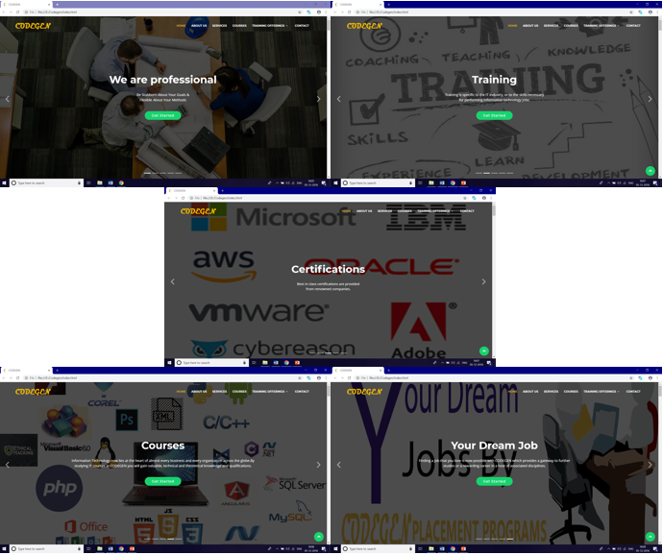

ABOUT US:

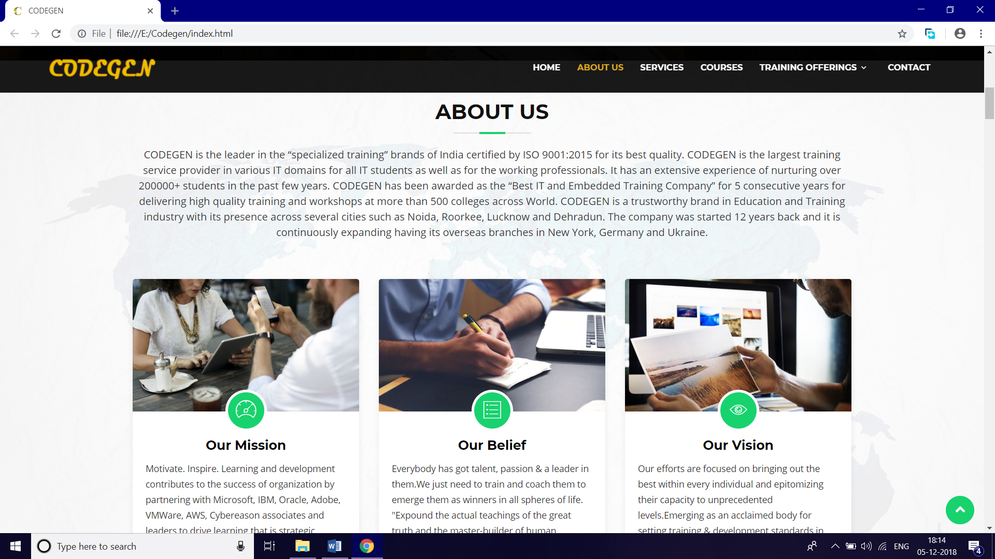

SERVICES:

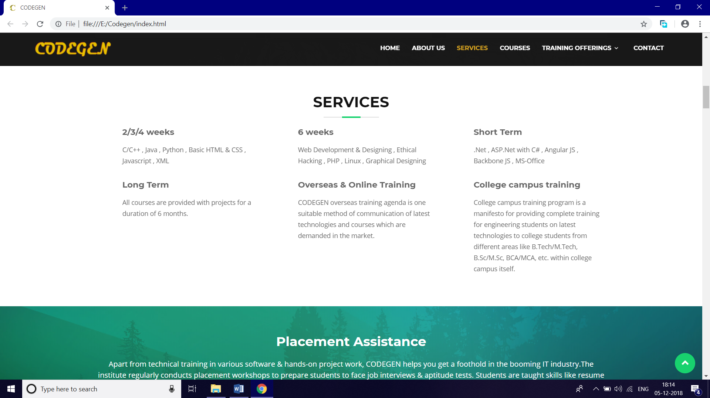

PLACEMENT:

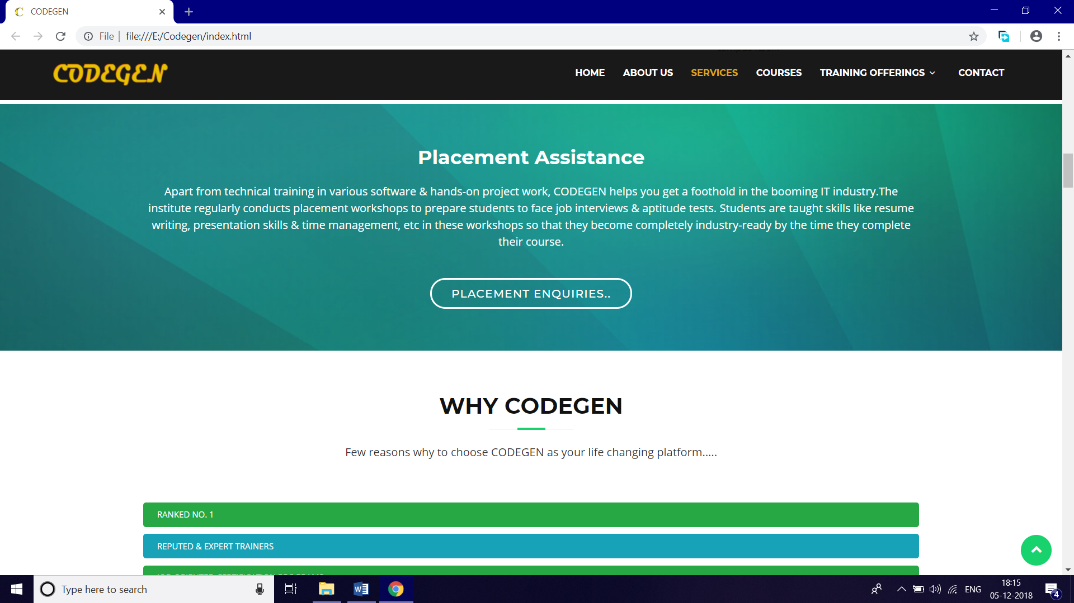

SKILLS:

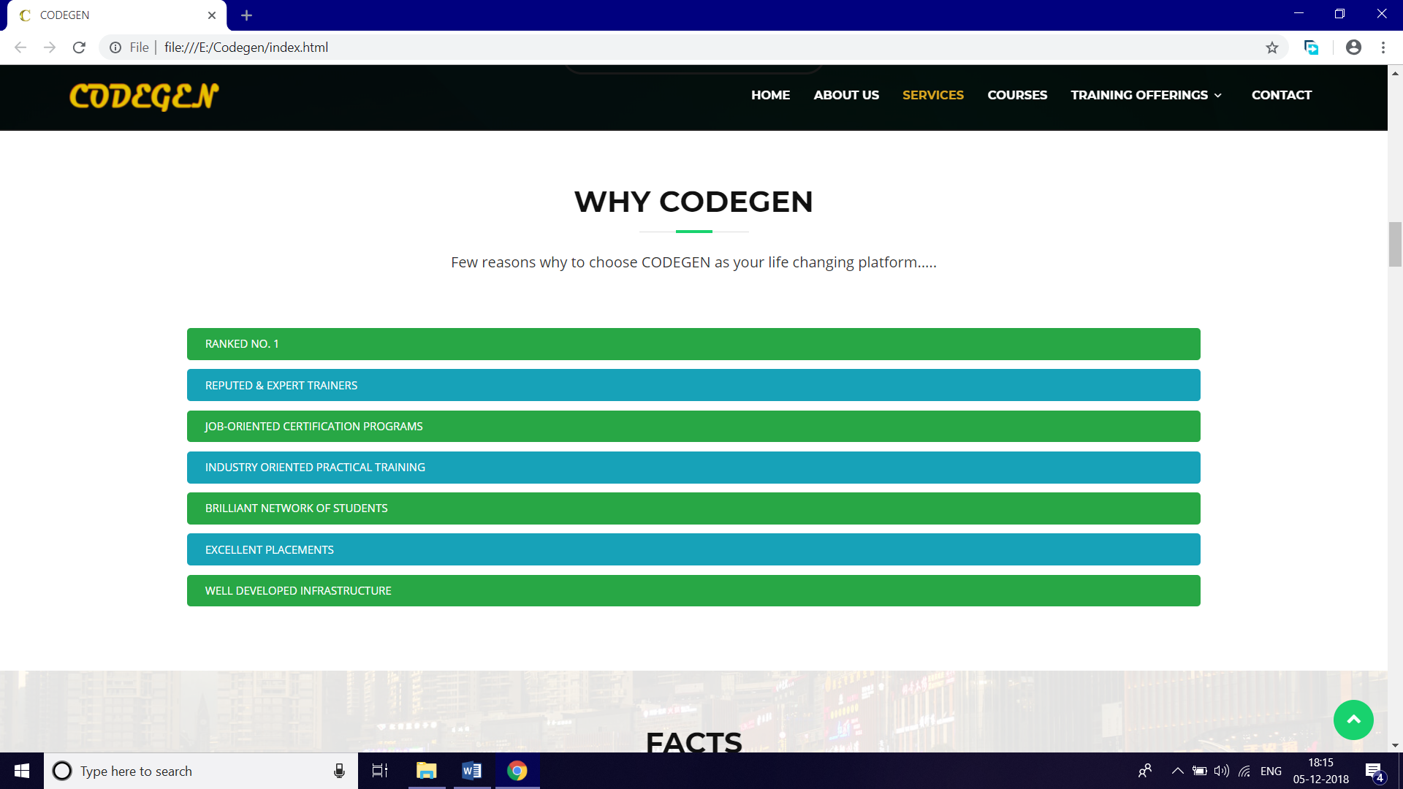

FACTS:

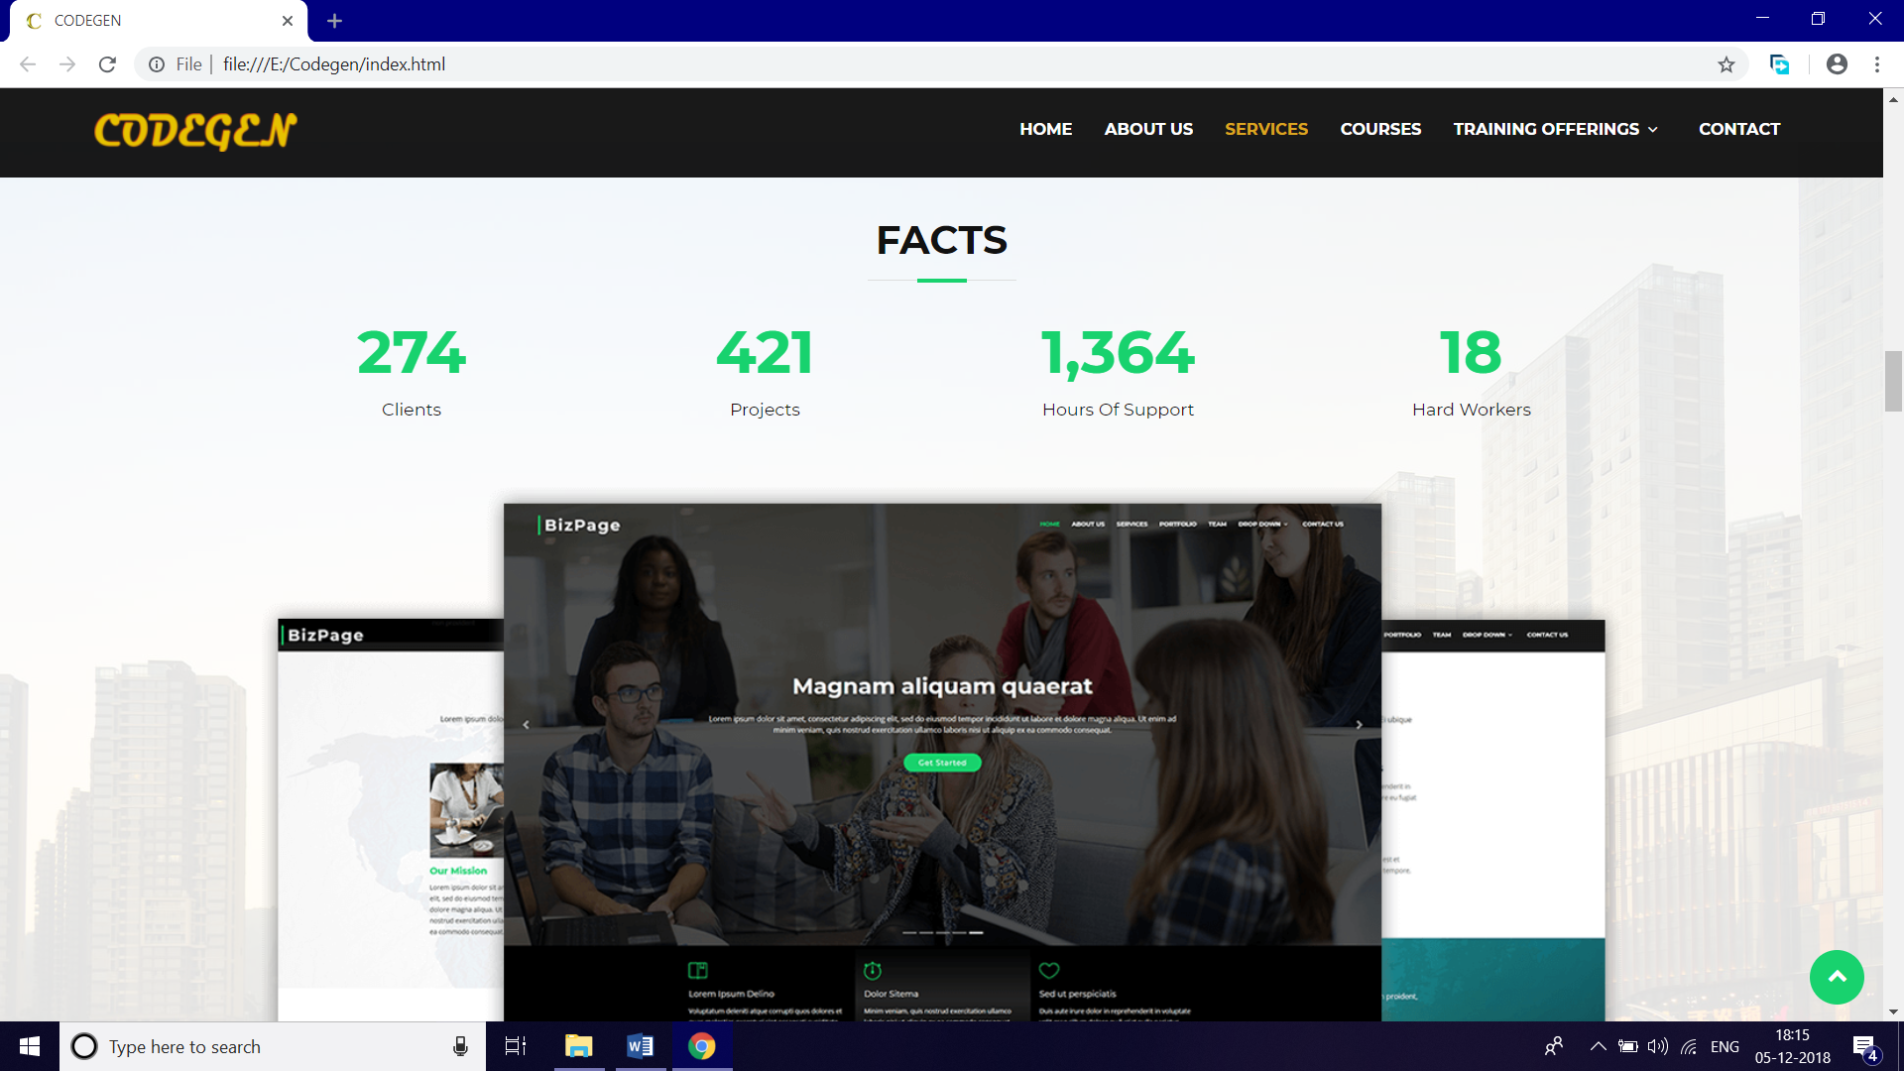

COURSES:

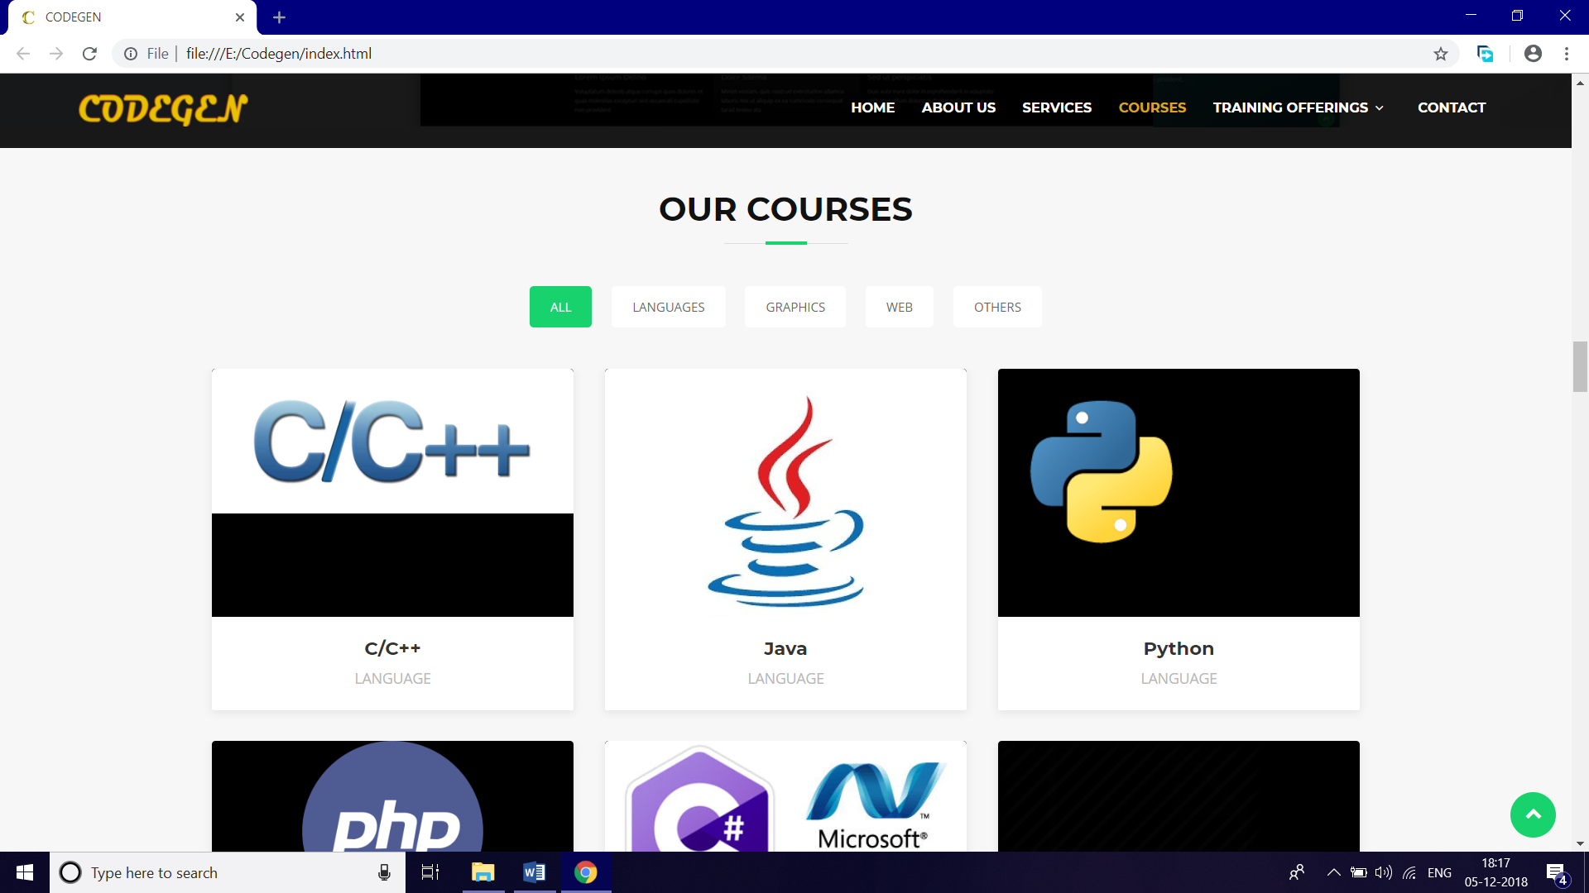

CLIENTS:

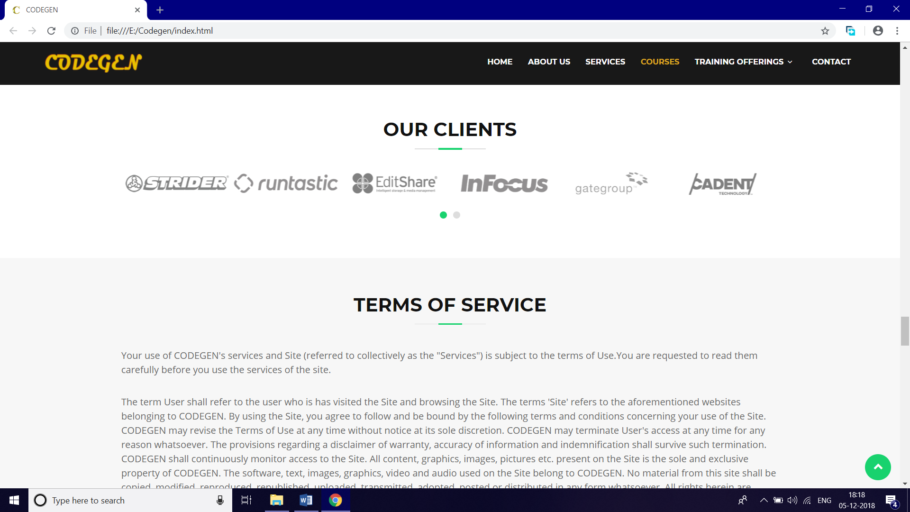

TERMS OF SERVICE:

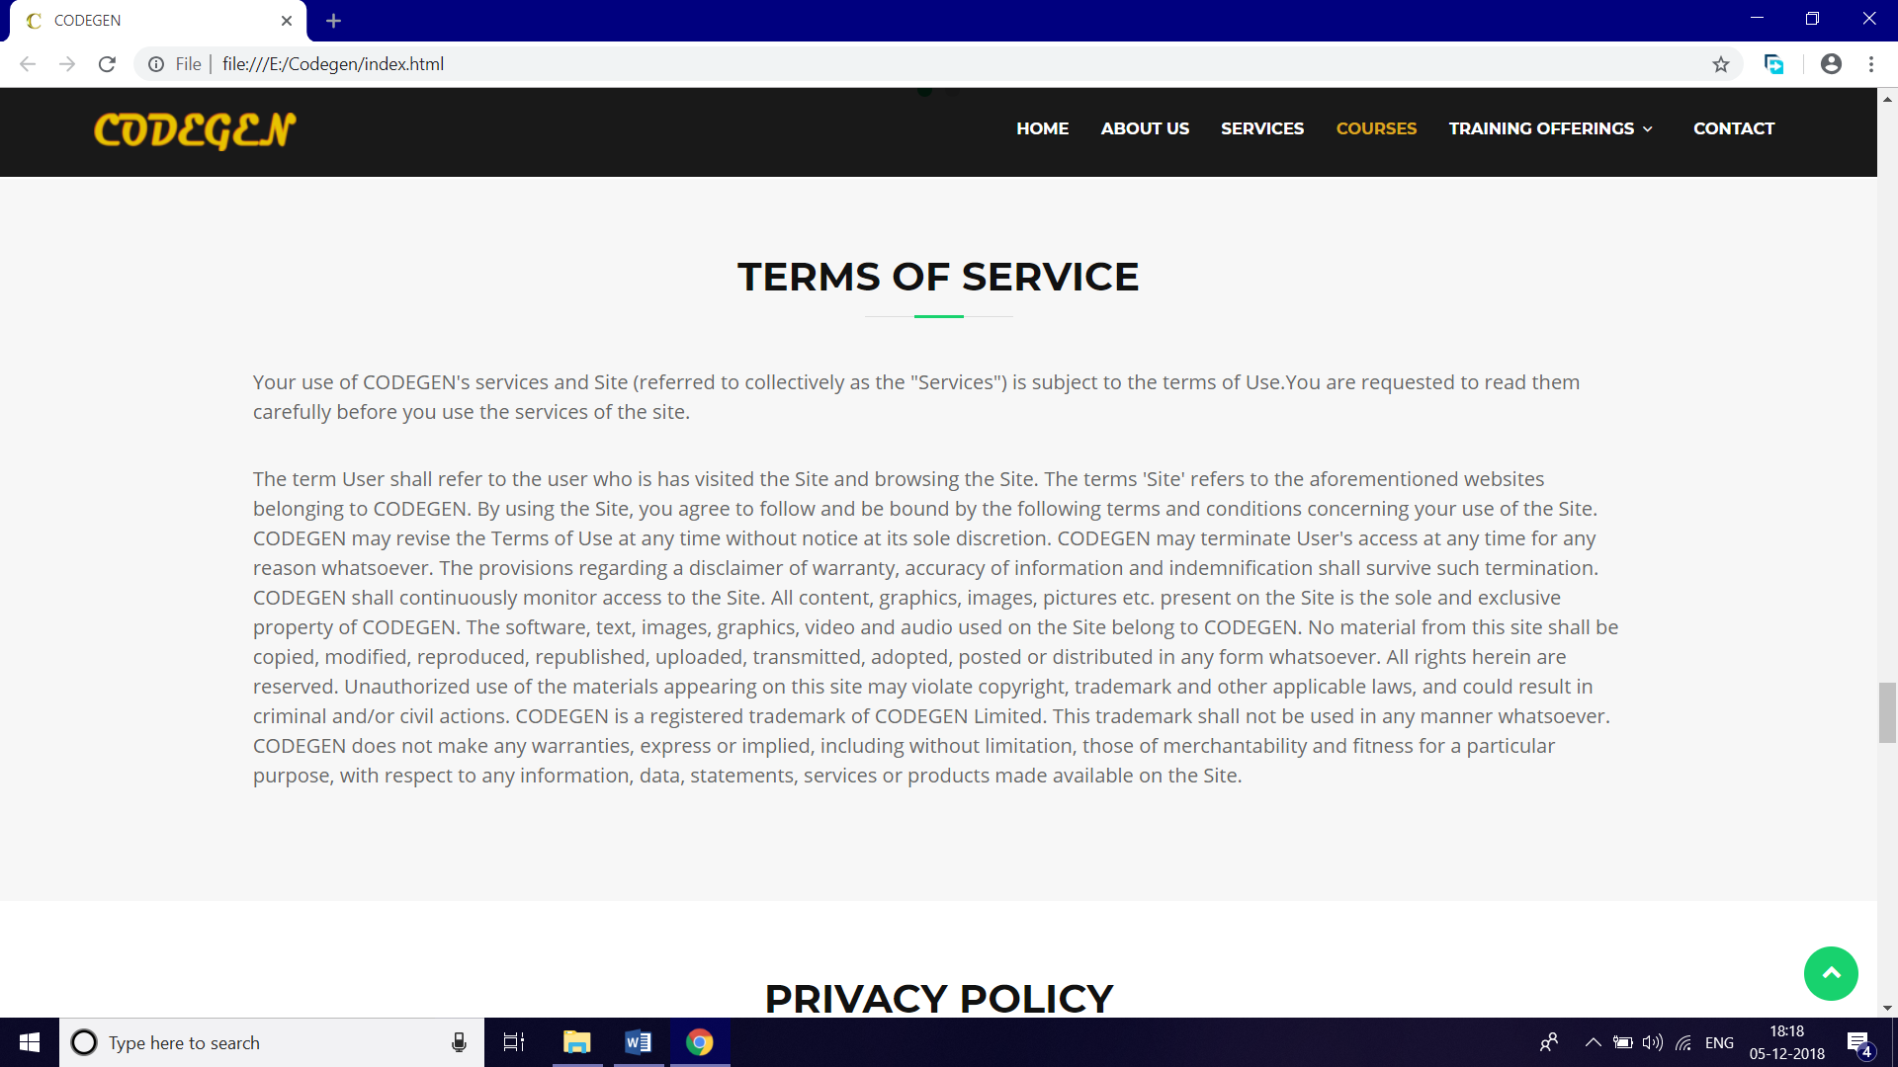

PRIVACY POLICY:

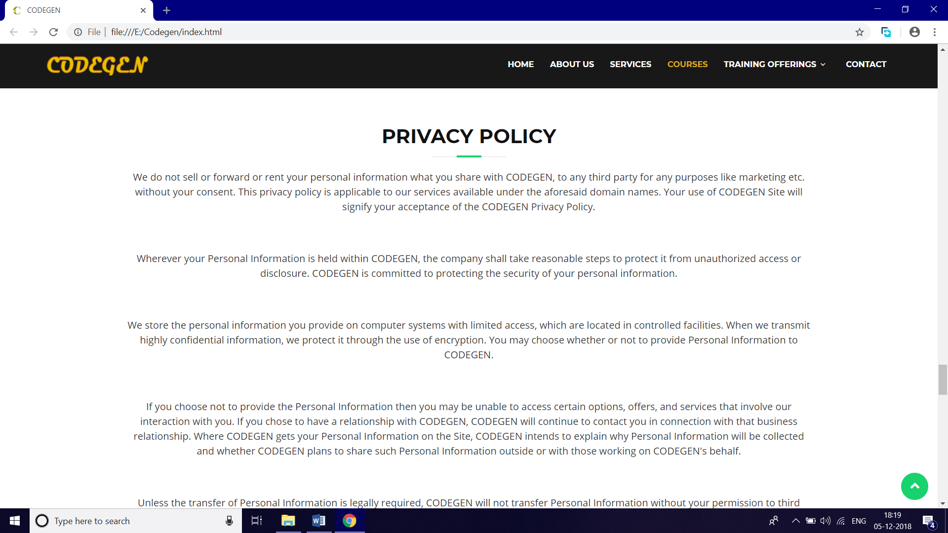

CONTACT US:

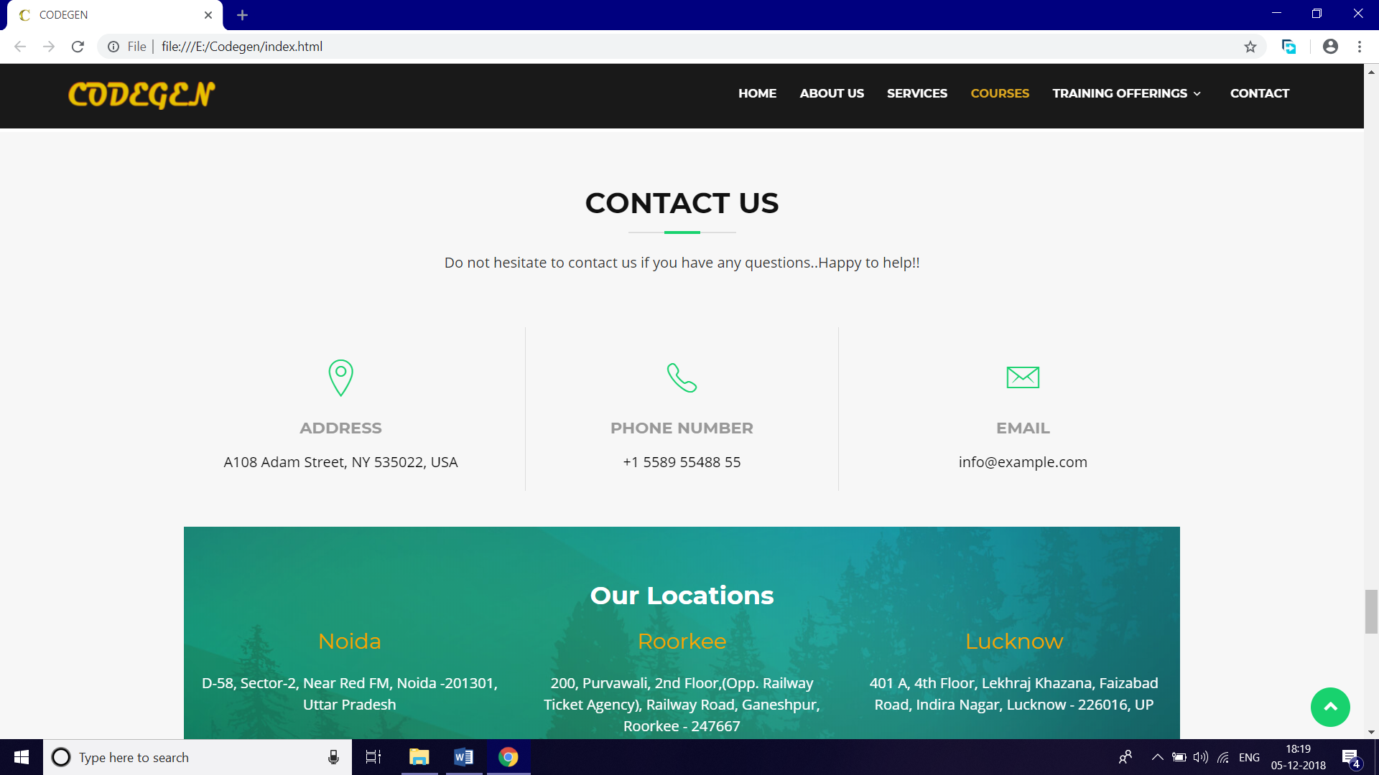

LOCATION:

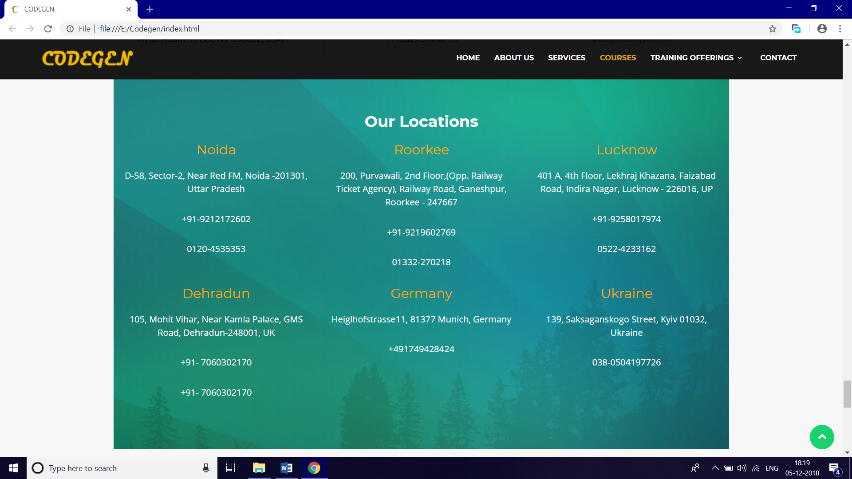

FOOTER:

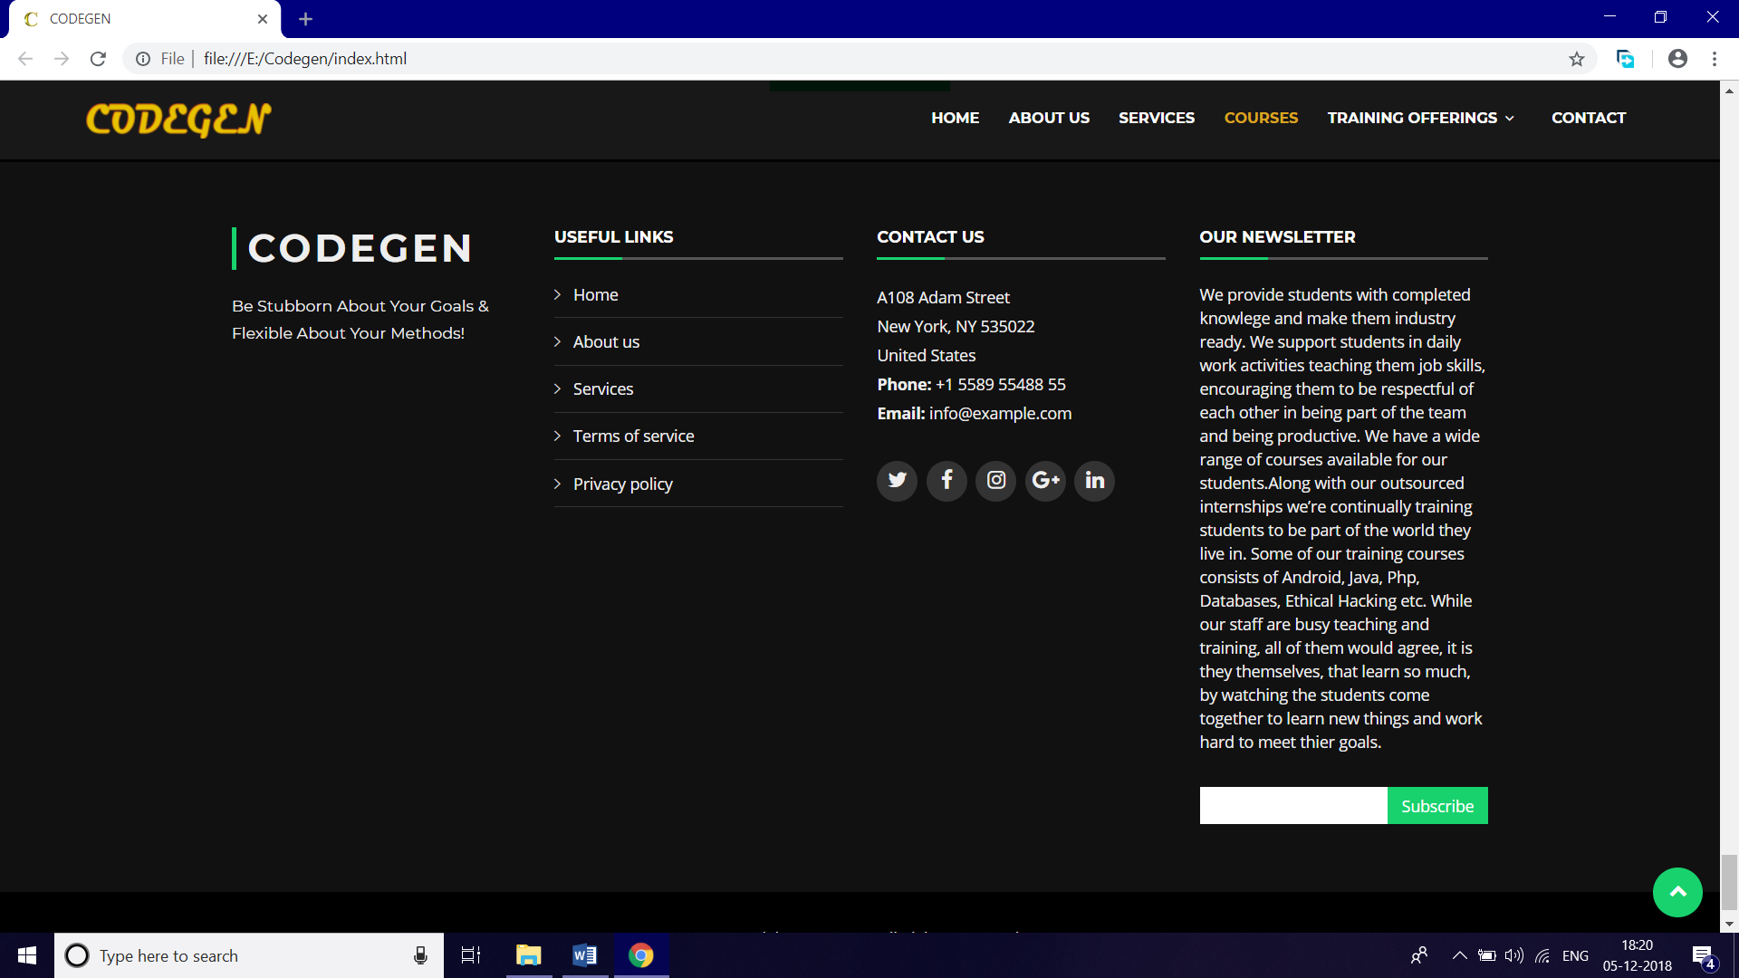

**References**

1. NIELIT faculty (IT department)
2. [www.w3schools.com](http://www.w3schools.com)
3. [www.Bootstrapmade.com](http://www.Bootstrapmade.com)
4. [www.wowslider.com](http://www.wowslider.com)